EVAN Toolbox Support Issues and Requests
25 November 2010

ETS 10/001. Reporter: PoH; Report Date: 17 Oct 10. Resolve Date:
Name: Two warpers in a vpn
Type: bug; Status: Open
Action log:
Description: Warper seems to screw up when two are active at once in a vpn .. in that case the registration between landmarks and surfaces screws up and if each is attached to a separate viewer, the two viewers get confused.. i often find objects in one or other viewer like the mean surface that i definitely have not sent there. Seems fixed by avoiding using two warper nodes and using realise node instead. Can we block the use of two warper nodes.. but how then will 2 block pls work? The warpers can also get confused in this network.

ETS 10/002. Reporter: PoH; Report Date: 17 Oct 10. Resolve Date: Nov 10
Name: Inconsistent open file dialogue boxes
Type: improvement; Status: Closed
Action log: HG Nov 10 - Fixed (although the save vpn dialog is still as the one below. It ‘s a bit complicated to change because of the “save states” checkbox)
Description: When opening a new vpn the dialogue is different from the dialogues when opening files .. it would be good if they matched throughout the toolkit . The second one below is best by far.
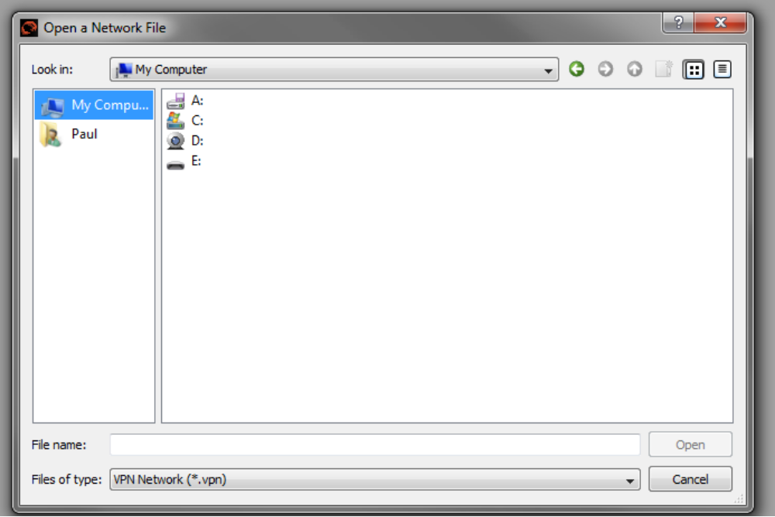
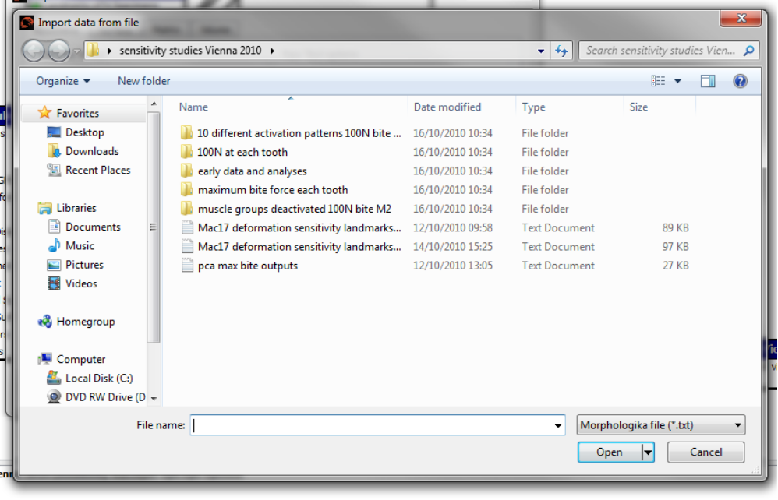

ETS 10/003. Reporter: PoH; Report Date: 17 Oct 10. Resolve Date:
Name: Turn off graph highlighting
Type: Improvement; Status: Open
Action log: RP Needs fixing but low priority.
Description: See below how the label and point go green. I can’t switch that off i.e. deselect points, so that I can grab a clean screen for publication .. we need to be able to unselect
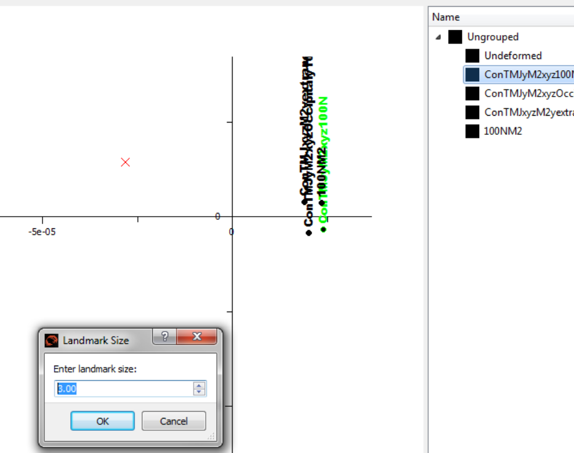

ETS 10/004. Reporter: PoH; Report Date: 17 Oct 10. Resolve Date:
Name: How to set symbol type for groups.
Type: User query; Status: Open
Action log:
Description: Even though I have groups in the morphologika file the data are not grouped, that means that I cannot change the symbol for all group members in one go, I have to do each separately. Is there a way to group the data? Do I have to also use the group specimens node?

ETS 10/005. Reporter: PoH; Report Date: 17 Oct 10. Resolve Date:
Name: Changing axis limits on graphs
Type: bug; Status: Open
Action log:
Description: When I try to set and change axes limits or expand the graph window, often the axes go weird, the graph gets clipped, and ‘set axes limits’ does not behave at all well. All sorts of messiness.

ETS 10/006. Reporter: PoH; Report Date: 17 Oct 10. Resolve Date:
Name: Axes thickness
Type: bug; Status: Open
Action log:
Description: Set axes thickness does not work

ETS 10/007. Reporter: PoH; Report Date: 17 Oct 10. Resolve Date:
Name: Loss of label marker settings
Type: bug; Status: Open
Action log: HG Nov 10 – unable to reproduce problem.
Description: When I set the font for labels or the shape to something other than ellipse and then switch to a plot of another pair of axes the font resets to the default and resizes to default and the shape resets. Very time consuming

ETS 10/008. Reporter: PoH; Report Date: 17 Oct 10. Resolve Date: Nov 10
Name: Axis labels disappear in 3D plotter
Type: bug; Status: Closed
Action log: HG Nov 10 – fixed.
Description: In the 3D graph plotter when square axes are set, the axis labels disappear

ETS 10/009. Reporter: PoH; Report Date: 17 Oct 10. Resolve Date:
Name: Viewer problems - various
Type: bug; Status: Open
Action log:
Description: In the viewer when you are resizing and/or rotating groups of grids after a while everything cocks up, the grids may disappear or rotate independently or even shear during a rotation etc many bugs, needs graphics wiz to fix.

ETS 10/010. Reporter: PoH; Report Date: 17 Oct 10. Resolve Date:
Name: GPA outputs
Type: bug; Status: Open
Action log: HG Nov 10 – Unable to replicate problem; problem, output file is created when new file name is set.
Description: I seem to only be able to print the gpa outputs if I begin with the gpa node output file specified, once run I cannot get the output if I declare a file.

ETS 10/011. Reporter: PoH; Report Date: 17 Oct 10. Resolve Date: Nov 10
Name: Misfit of landmarks to surface
Type: bug; Status: Closed
Action log: HG Nov 10 – fixed.
Description: Check problem of misfit of landmarks to surfaces in the Vienna workshop October data .

ETS 10/012. Reporter: PoH; Report Date: 17 Oct 10. Resolve Date:
Name: Regression node
Type: bug; Status: Open
Action log:
Description: There is a bug in the regression node, in example data.txt the sexes are ‘ male’ and ‘female’. Somehow they are recoded ? as 0, 1? Anyway, when subsequently warping along the regression of shape on sex the warpings seem very extreme, ie, 0, looks like a male but a female seems complete by 0.2 or so, not 1. What is going on?

ETS 10/013. Reporter: PoH; Report Date: 17 Oct 10. Resolve Date:
Name: Two click landmarking is tedious
Type: improvement; Status: Open
Action log:
Description: In Templand two clicks for landmarking is tedious, can it be one click? Does this cause other problems.

ETS 10/014. Reporter: PoH; Report Date: 17 Oct 10. Resolve Date:
Name: Incorrect warping when GPA parameters scale / rotate / translate deselected
Type: bug; Status: Open
Action log:
Description: When in GPA and I deselect scaling or rotation or translation and then do a PCA (pcaplotwarp.vpn). In the viewer the surface and landmarks just translate rather than warp between the selected start and end points. If scaling is deselected the viewer should contain a surface; that and landmarks will scale as you warp between points if a size difference is also present.

ETS 10/015. Reporter: PoH; Report Date: 17 Oct 10. Resolve Date: Nov 10
Name:
Type: bug; Status: Closed
Action log: Fixed, changed “landmark size” to “marker size” comment in dialogue box.
Description: In the plotter when you try to change the size of symbols the following dialogue appears.
These are symbols, not landmarks and the text for the window heading and in the window needs changing .

